**Crypto Bareksa - Mobile Apps - Phase 1**

| **Document Version** | V.1.0.0 |
| --- | --- |
| **Project Name** | **Crypto Bareksa Consumer Mobile App**  **> iOS**  **> Android** |
| **PM** | [fury oktria](mailto:furyoktriaputra@gmail.com) |
| **Designer** | N/A |
| **Engineering Manager/ Tech Lead** | @fury_engineering_manager |
| **Engineering Squad** | @fury_front_end_engineer  @fury_back_end_engineer  @fury_mobileengineer_iOS  @fury_mobileengineer_android |
| **Date Created** | Sep 8, 2024 |

**Background**

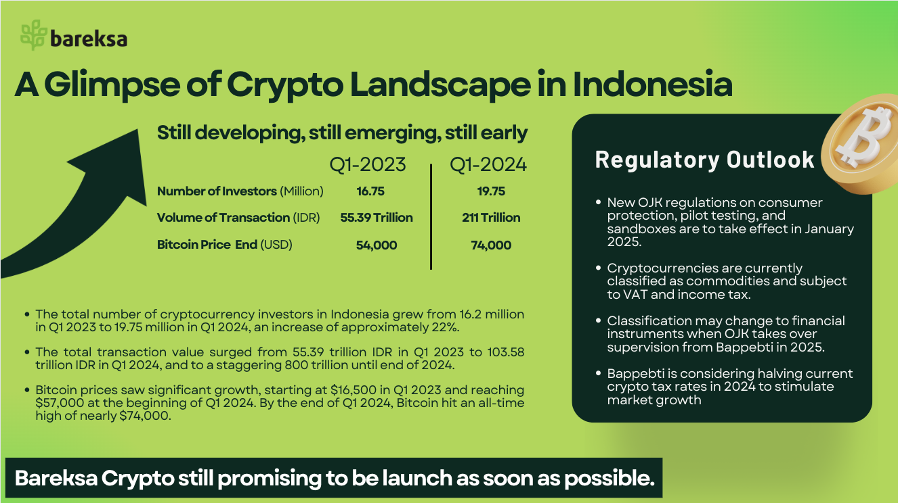

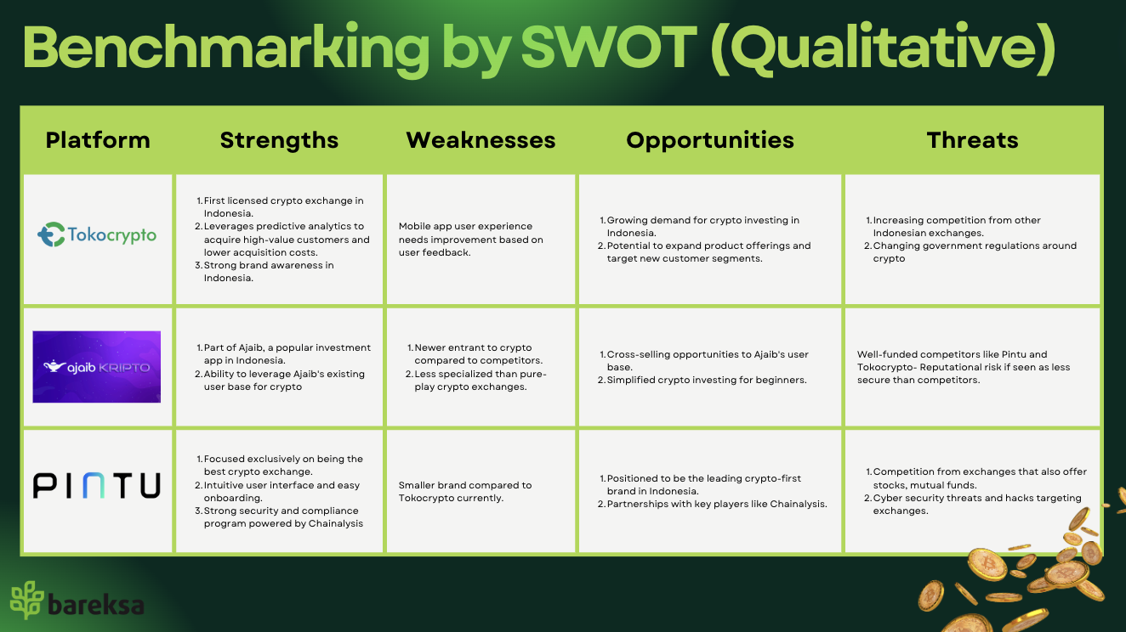

**User**

| **User Segment** | **Description** | **Needs and Preferences** |
| --- | --- | --- |
| **Retail Investors (P0)** | Individual investors looking to diversify their portfolio with cryptocurrencies, especially those coming from Bareksa investors. | 1. User-friendly interface. 2. Educational resources. 3. Low fees and minimum investments. 4. Secure wallet and storage options. |
| **Traders (P2)** | Active traders seeking to profit from cryptocurrency price movements. | 1. Advanced trading features (e.g., margin trading, stop-loss orders). 2. Real-time market data and charts. 3. Low trading fees and high liquidity. 4. API access for automated trading. |
| **Institutional Investors (P4)** | Financial institutions, and investment firms allocate capital to cryptocurrencies. | 1. Institutional-grade security and compliance. 2. High liquidity and OTC (Over-the-Counter) trading. 3. Customized reporting and account management. 4. Dedicated customer support |
| **Beginners (P1)** | New investors seeking an easy entry point into cryptocurrency investing. | 1. Simple and intuitive user interface. 2. Educational content and guides. 3. Demo accounts and low minimum investments. 4. Customer support and help center. |

**Goal**

| **Category** | **Deliverables** | **Metrics** |
| --- | --- | --- |
| iOS mobile app | > Develop a native iOS app compatible with iPhones running iOS 14 or later. | **> App Store rating**  Aim for a 4.5-star rating or higher.  **> App stability:**  Ensure a crash-free rate of 99.5% or higher.  **> User acquisition:**  Achieve 10,000 app downloads within the first 3 months of launch. |
| Android mobile app | > Develop a native Android app compatible with devices running Android 7.0 (Nougat) or later. | **> Google Play Store rating**  Aim for a 4.5-star rating or higher.  **> App stability**  Ensure a crash-free rate of 99.5% or higher.  **> User acquisition**  Achieve 15,000 app downloads within the first 3 months of launch. |

**Scope - Platform Registration**

| **Feature Name** | **User Story** | **Acceptance Criteria** | **User Interface** |
| --- | --- | --- | --- |
| User Registration | As a new user, I want to create an account using Google SSO account so that I can access the Bareksa Crypto app features. | **Scenario: Successful user registration**  > Given I am on the registration page.  > When I enter valid registration details.  > And I submit the registration form.  > Then I should see a success message.  > And I should be redirected to the app home screen. | <https://motiff.com/file/U6C62qQY2ao4AIBwmKh0G4h?nodeId=2%3A0&type=design> |
| User Login | As a registered user, I want to log in to my account so that I can access my wallet and perform transactions. | **Scenario: Successful login**  >Given I am on the login page.  > When I enter my registered email address.  > And I enter my correct password.  > And I tap on the "Login" button.  > Then I should be redirected to the app home screen. |

**Scope - Crypto Account Registration**

| **Feature Name** | **User Story** | **Acceptance Criteria** | **User Interface** |
| --- | --- | --- | --- |
| Identity Verification | As a registered user, I want to verify my identity so that I can comply with KYC regulations and start trading. | **Scenario: Successful identity verification**  > Given I am on the identity verification page  > When I upload a clear photo of my valid government ID  > And I upload a selfie holding my ID  > And I submit the verification form  > Then I should see a message that my verification is being processed  > And I should receive an email confirmation of my submission  **Scenario: Failed identity verification**  >Given I am on the identity verification page.  > When I upload an unclear or invalid ID photo.  > And I submit the verification form.  > Then I should see an error message explaining the issue.  > And I should be prompted to resubmit with correct documentation. | https://motiff.com/file/U6C62qQY2ao4AIBwmKh0G4h?nodeId=2%3A301&type=design |
| Bank Account Registration | As a verified user, I want to register my bank account so that I can deposit and withdraw fiat currency. | **Scenario: Successful bank account registration**  > Given I am logged in and verified.  > When I navigate to the bank account registration page  > And I enter my valid bank account details.  > And I submit the bank account registration form.  > Then I should see a success message.  > And my bank account should be listed in my profile.  **Scenario: Invalid bank account details**  > Given I am on the bank account registration page.  > When I enter invalid bank account details.  > And I submit the bank account registration form.  > Then I should see an error message indicating invalid bank details. |
| Two-Factor Authentication Setup using Google Authenticator | As a user, I want to set up 2FA so that I can add an extra layer of security to my account. | **Scenario: Successful 2FA setup with Google Authenticator App**  > Given I am logged in and on the security settings page.  > When I choose to enable 2FA with Google authenticator app.  > And I scan the QR code with my authenticator app.  > And I enter the correct 2FA code.  > Then I should see a confirmation that 2FA is enabled.  > And I should be prompted to save backup codes.  **Scenario: Failed 2FA setup**  > Given I am on the 2FA setup page.  > When I enter an incorrect 2FA code.  > Then I should see an error message.  > And I should be prompted to try again. |

**Scope - Top-up Balance for Crypto Trading**

| **Feature Name** | **User Story** | **Acceptance Criteria** | **User Interface** |
| --- | --- | --- | --- |
| Balance Management | As a user, I want to view and manage my balance within the Bareksa Crypto app. | **Scenario: Viewing balances**  > Given I am logged into the Bareksa Crypto app.  > When I navigate to the balance page.  > Then I should see my current fiat balance.  > And I should see a list of my cryptocurrency balances.  **Scenario: Depositing Balance**  > Given I am on the balance page.  > When I select "Deposit".  > And I choose a deposit method.  > And I enter the deposit amount.  > And I confirm the deposit.  > Then I should see a confirmation of my deposit request.  > And my fiat balance should be updated once the deposit is processed.  **Scenario: Withdrawing fiat currency**  > Given I am on the balance page.  > When I select "Withdraw Fiat".  > And I enter the withdrawal amount.  > And I choose a withdrawal method.  > And I confirm the withdrawal.  > Then I should see a confirmation of my withdrawal request.  > And my fiat balance should be updated once the withdrawal is processed. | [**https://motiff.com/file/U6C62qQY2ao4AIBwmKh0G4h?nodeId=2%3A482&type=design**](https://motiff.com/file/U6C62qQY2ao4AIBwmKh0G4h?nodeId=2%3A482&type=design) |
| Manual Buy Cryptocurrency | As a user, I want to buy cryptocurrency using my fiat balance in the Bareksa Crypto app. | **Scenario: Successful cryptocurrency purchase**  > Given I am logged into the Bareksa Crypto app  > And I want to buy cryptocurrency.  > When I navigate to the buy cryptocurrency page.  > And I select a cryptocurrency to buy.  > And I enter the amount of fiat currency to spend.  > And I confirm the transaction.  > Then I should see a confirmation of my purchase.  > And my fiat balance should be reduced by the purchase amount.  > And my cryptocurrency balance should be increased by the purchased amount.  **Scenario: Failed purchase due to insufficient fiat balance**  > Given I am on the buy cryptocurrency page.  > When I attempt to buy cryptocurrency with insufficient balance.  > Then I should see an error message about insufficient funds.  > And the transaction should not be processed  And my balances should remain unchanged.  **Scenario: Buying cryptocurrency with a limit order**  > Given I am on the buy cryptocurrency page.  > When I select a cryptocurrency to buy.  > And I enter the amount and desired price for a limit order.  > And I confirm the limit order.  > Then I should see a confirmation of my limit order placement.  > And the order should be added to the order book.  > And my available fiat balance should be reduced by the potential purchase amount. |
| Manual Sell Cryptocurrency | As a user, I want to sell my cryptocurrency and receive the proceeds in my fiat balance within the Bareksa Crypto app. | **Scenario: Successful cryptocurrency sale**  > Given I am logged into the Bareksa Crypto app  > And I have sufficient cryptocurrency balance.  > When I navigate to the sell cryptocurrency page.  > And I select a cryptocurrency to sell.  > And I enter the amount of cryptocurrency to sell.  > And I confirm the transaction.  > Then I should see a confirmation of my sale  And my cryptocurrency balance should be reduced by the sold amount  And my fiat balance should be increased by the sale proceeds  **Scenario: Failed sale due to insufficient cryptocurrency balance**  > Given I am on the sell cryptocurrency page.  > When I attempt to sell more cryptocurrency than I have in my balance.  > Then I should see an error message about insufficient balance.  > And the transaction should not be processed.  > And my balances should remain unchanged.  **Scenario: Selling cryptocurrency with a limit order**  > Given I am on the sell cryptocurrency page.  > When I select a cryptocurrency to sell.  > And I enter the amount and desired price for a limit order.  > And I confirm the limit order.  > Then I should see a confirmation of my limit order placement.  > And the order should be added to the order book.  > And my available cryptocurrency balance should be reduced by the potential sale amount. |
| Order Types | As a trader, I want to use various order types when buying or selling cryptocurrencies to optimize my trading strategy. | **Scenario: Placing a market order**  >Given I am on the order placement interface.  > When I select a cryptocurrency and transaction type (buy/sell).  > And I enter the amount for a market order.  > And I confirm the market order.  > Then I should see a confirmation of my market order execution.  > And my balances should be updated immediately.  **Scenario: Placing a stop loss order**  > Given I am on the order placement interface.  > When I select a cryptocurrency and "Sell" as the transaction type.  > And I enter the amount and stop price for a stop loss order.  > And I confirm the stop loss order.  > Then I should see a confirmation of my stop loss order placement.  > And the order should be activated when the stop price is reached.  **Scenario: Placing a take profit order**  > Given I am on the order placement interface.  > When I select a cryptocurrency and "Sell" as the transaction type.  > And I enter the amount and take profit price.  > And I confirm the take profit order.  > Then I should see a confirmation of my take profit order placement.  > And the order should be activated when the take profit price is reached.  **Scenario: Placing a trailing stop order**  > Given I am on the order placement interface.  > When I select a cryptocurrency and "Sell" as the transaction type.  > And I enter the amount and trailing stop distance.  > And I confirm the trailing stop order.  > Then I should see a confirmation of my trailing stop order placement.  > And the trailing stop price should adjust as the market price moves up. |

**Scope-Portfolio Tracking**

| **Feature Name** | **User Story** | **Acceptance Criteria** | **User Interface** |
| --- | --- | --- | --- |
| Cryptocurrency Portfolio Display | As a user, I want to see a clear overview of my cryptocurrency holdings so that I can easily track my investments. | **Scenario: Viewing cryptocurrency as a whole**  > Given I am logged into the Bareksa Crypto app.  > When I navigate to the portfolio page.  > Then I should see a list of all cryptocurrencies I have.  > And for each cryptocurrency, I should see:  * The name and ticker symbol  * The quantity I own  * The current price per unit  **Scenario: Empty portfolio display**  > Given I am a new user with no cryptocurrency purchases.  > When I navigate to the portfolio page.  > Then I should see a message indicating I have no holdings yet.  > And I should see a prompt to make my first purchase. | <https://motiff.com/file/U6C62qQY2ao4AIBwmKh0G4h?nodeId=402%3A3&type=design> |

**Scope-Notification**

| **Feature Name** | **User Story** | **Acceptance Criteria** | **User Interface** |
| --- | --- | --- | --- |
| Account Activity Push Notifications | As a user, I want to receive push notifications for important account activities so that I can stay informed about my transactions in real-time. | **Scenario: Deposit notification**  > Given I have enabled push notifications.  > When a deposit to my account is completed.  > Then I should receive a push notification.  > And the notification should display the deposited amount and currency.  **Scenario: Withdrawal notification**  > Given I have enabled push notifications.  > When a withdrawal from my account is processed.  > Then I should receive a push notification.  > And the notification should display the withdrawn amount and currency.  **Scenario: Trade execution notification**  > Given I have enabled push notifications.  > When one of my trade orders is executed.  > Then I should receive a push notification.  > And the notification should display the trade details (buy/sell, amount, price.  **Scenario: Disabling push notifications**  > Given I have previously enabled push notifications.  > When I turn off push notifications in the app settings.  > Then I should stop receiving push notifications for account activities. | [**https://motiff.com/file/U6C62qQY2ao4AIBwmKh0G4h?nodeId=402%3A286&type=design**](https://motiff.com/file/U6C62qQY2ao4AIBwmKh0G4h?nodeId=402%3A286&type=design) |
| In-App Notifications | As a user, I want to receive in-app notifications for updates and promotions so that I can stay informed about new features and opportunities within the app. | **Scenario: Viewing new in-app notification**  > Given I am logged into the app.  > When there is a new update or promotion.  > Then I should see a notification indicator on the app's notification center icon.  > And when I open the notification center, I should see the new notification at the top.  **Scenario: Reading an in-app notification**  > Given I have unread notifications in the notification center.  > When I tap on a notification.  > Then I should be taken to the relevant page or see a detailed view of the notification.  > And the notification should be marked as read.  **Scenario: Clearing all notifications**  > Given I have multiple notifications in the notification center.  > When I choose the "Clear All" option.  > Then all notifications should be removed from the notification center.  > And the notification indicator should disappear. |  |

**Technical Concern**

1. Payment Gateway, using Xendit to enable Payment Options for Top-up Balance.

2. Using openwareOpenDax as the Crypto Engine.